

Interactive Health Solutions

QR Code Generator

User Manual

Contents

1. Introduction 3

2. How to use 3

2.1 Serial Version 3

2.2 Random Version 5

3. Output 6

# Introduction

QR Code Generator is open source web based application developed by Interactive Health Solutions. It allows user to create unique QR Codes in two formats i.e. Serial and Random Numbers. It takes input from the user on the form. The input is then processed and PDF file is generated which contains the required QR Codes. Once the PDF file is generated all the codes are inserted into the database to keep the record of QR Codes along with its time stamp.

# How to use

## Serial Version

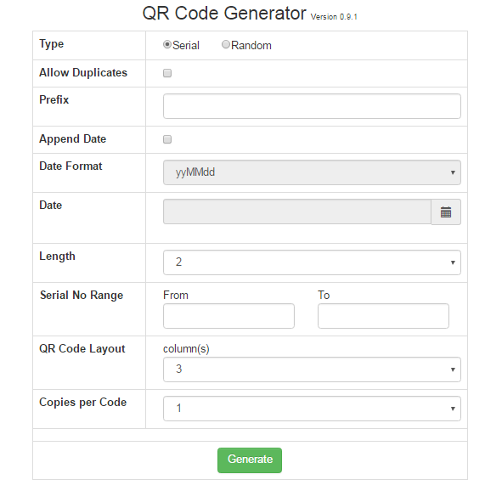

* **Type:** This is the required format in which user wish to generate QR Codes. This can be either Serial or Random.
* **Allow Duplicates:** This is the check if user wants to allow duplicate QR Code. If it is checked it means that the QR Code which has been created before can be created again. If it is not checked system will not allow to create duplicate QR Code and will show error.
* **Prefix:** This is the first alphanumeric character/word in QR Code. If user wants to add something in the start he can add in this field else this field can be left empty.
* **Append Date:** This is check if user wants to append date in the QR Code. If it is checked user can append date in the QR Code else user will not be allowed to append date in the QR Code.
* **Date Format:** This is the date format in which the date will be appended in the QR Code. This option is only enabled if Append Date option is checked.
* **Date:** This option allows user to select date. Minimum date year can be 1970. This option is only enabled if Append Date option is checked.
* **Length:** This is the length of serial number which will be appended in the QR Code. Minimum length can be 2 and maximum length can be 6.
* **Serial No Range:** This is the range of serial numbers. “From” is the starting range and “To” is the ending range.
* **QR Code Layout:** This option allows user to select the number of QR Codes in single column in generated PDF file. Minimum number of QR Codes in single column can be 3 and maximum number of QR Codes in single column can be 6.
* **Copies per Code:** This option allows user to select the number of multiple copies of single QR Code he needs in the generated PDF file.
* **Generate Button:** This buttons allows user to generate PDF file. If data is entered correctly PDF file will be generated else system will show the corresponding error.

## Random Version

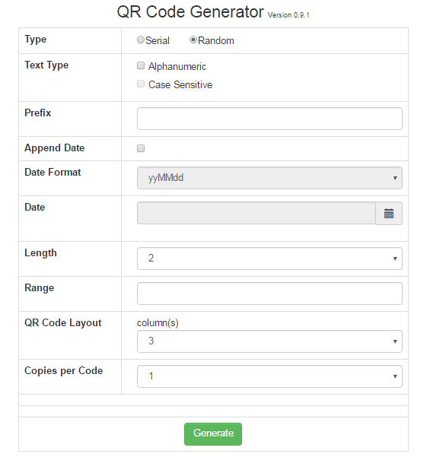

This is the random number version which allows user to generate QR Codes using random numbers. This form is quite similar to Serial version form. New fields are described below:

* **Text Type:** This is the type of random number user wants in the QR Code. This can be numeric, alphanumeric or case sensitive alphanumeric. If both the options are left unchecked numeric random number will be appended in the QR Code. If alphanumeric is checked then alphanumeric random

number will be appended in the QR Code. Case sensitive option is only enabled if alphanumeric option is checked. If this option is checked then case sensitive alphanumeric number will be appended in the QR Code which includes number, small alphabets and capital alphabets.

* **Range:** This is the number of QR Codes user wants in the generated PDF file. Maximum number of QR Codes in numeric can be 10 ^ length. As there are 10 digits i.e. 0-9. Similarly in case of alphanumeric it will be 36 ^ length i.e. 26 for alphabets and 10 for digits and in case of case sensitive it will be 62 ^ length i.e. 26 for small letters, 26 for capital letters and 10 for digits.

# Output

Below is the snapshot of generated PDF file:

